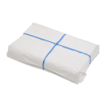
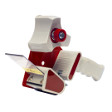
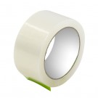
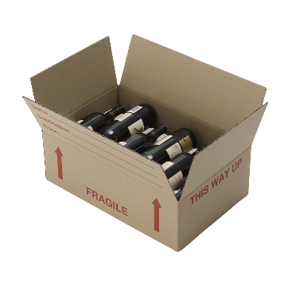
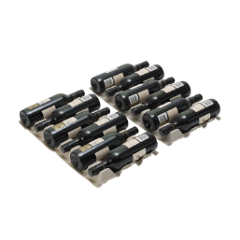
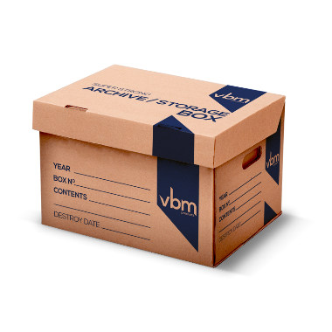
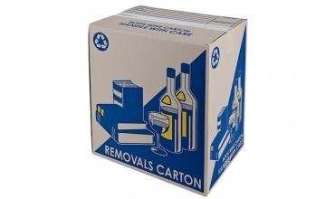
SIMPLY INDICATE NEXT TO EACH ITEM QUANTITY REQUIRED AND EMAIL TO
FREELING STOWAWAY STOCKLIST/ORDER FORM
freelingstowaway@bigpond.com and your order will be confirmed and invoiced for payment. Alternatively order via the Enquiry form on our website at www.freelingstowaway.com.au.
All Prices are GST Inclusive and subject to change

